Agentic Case Management
Notation
ACMN

Version 1.0 — First Working Draft
April 2026
An open standard extending CMMN (Case Management Model and Notation)
with native primitives for AI agent orchestration.
acmnstandard.org
Status: Working Draft — Not yet submitted for standardisation

1. Scope
This specification defines the Agentic Case Management Notation (ACMN), a notation for modelling case management processes that include autonomous AI agents as first-class participants alongside human actors. ACMN extends the Case Management Model and Notation (CMMN) 1.1 standard, published by the Object Management Group (OMG), by adding elements for agent orchestration, tool integration, confidence-driven progression, and domain context management.
ACMN preserves CMMN’s core concepts and terminology — cases, stages, sentries, milestones, case files, human tasks, and discretionary items — and adds new elements where CMMN provides no equivalent: agent nodes, tool nodes, guardrail nodes, handoff nodes, typed data wires, and domain contexts.
The scope of this specification includes:
- The ACMN metamodel: the elements, their attributes, and their relationships.
- State models: the lifecycle of cases, plan items, and agent instances.
- The sentry model: on-parts, if-parts, composition operators, and evaluation semantics.
- The milestone model: criteria types, achievement, revocation, and snapshot semantics.
- The wire model: typed data flow, buffering, transforms, and activation coupling.
- The event model: event types, delivery scopes, and subscription semantics.
- The domain context model: vocabulary, schemas, rules, and context mapping.
- The visual notation: the graphical representation of ACMN elements on a design surface.

This specification does not define a runtime implementation, serialisation format, API, or tooling. Implementations of ACMN are free to make their own technology choices for execution, persistence, and user interface, provided they conform to the metamodel and semantics defined herein.

2. Normative references
- OMG Case Management Model and Notation (CMMN) Version 1.1, formal/2016-12-01
- OMG Decision Model and Notation (DMN) Version 1.4, formal/2023-12-01
- OMG Unified Modeling Language (UML) Version 2.5.1, formal/2017-12-05
- OMG Business Process Model and Notation (BPMN) Version 2.0.2, formal/2013-12-10
- Eric Evans, Domain-Driven Design: Tackling Complexity in the Heart of Software, 2003
- Model Context Protocol (MCP) Specification, Anthropic, 2024

3. Terms and definitions
Terms defined by CMMN 1.1 retain their CMMN definitions. The following additional terms are defined by ACMN:
Agent: An autonomous AI participant in a case that reasons across multiple turns, uses tools, builds confidence, and collaborates with other agents and human actors. An agent is implemented by a large language model (LLM) but is specified in the notation as a set of behavioural properties independent of any specific model or provider.
Confidence: A numeric score (0.0 to 1.0) representing an agent’s self-assessed certainty in its conclusions. Confidence is recalculated after each agent turn and has a trajectory (rising, falling, oscillating, stable) computed over a sliding window.
Case intake: The process of receiving a signal from an external source, evaluating whether it represents a new case, extracting initial case data, and instantiating the case. An intake definition sits outside (and upstream of) the case plan model.
Cognitive mode: A metadata annotation on a stage indicating the type of reasoning expected: gather, analyse, draft, review, or decide. Cognitive modes are informational and do not alter execution semantics, but may be used by implementations to guide agent prompt assembly.
Decision model: A collection of decision tables within a domain context that codify how specific decisions are made in the domain. Decision models provide structured, auditable decision logic that agents can reference during reasoning.
Decision table: A tabular representation of decision logic with input columns (conditions), output columns (results), and rows (rules). Each row defines: when these input conditions are met, produce these outputs. Decision tables follow DMN semantics for hit policies and expression evaluation.
Domain context: A bounded context (in the Domain-Driven Design sense) that provides vocabulary, entity schemas, value object schemas, domain rules, decision models, and other domain-specific elements for a business domain. A case is bound to exactly one domain context.
Evaluation: An independent quality assessment of an agent’s output against defined criteria. Evaluation differs from guardrail checking (which tests binary constraints) and from self-reflection (which uses the same agent). An evaluation produces per-criterion scores and natural language feedback that can be returned to the agent for revision.
Guardrail: A constraint applied to agent output before it is committed to the case file. A guardrail evaluates output against rules and produces a pass, fail, or review result.
Handoff: A structured transfer of context from one case participant (agent or human) to another, comprising selected case file items, reasoning traces, and confidence history.
Intake agent: A specialised agent that evaluates incoming signals from external sources, classifies them, extracts structured data, and determines whether a new case should be created. The intake agent operates outside the case plan model, upstream of case instantiation.
Intake queue: A staging area between the intake agent’s positive classification and case instantiation. Items in the queue may be reviewed by humans, deduplicated, batched, or routed before cases are created.
Port: A named, typed connection point on a plan item. Ports are either input ports (receiving data) or output ports (producing data). Ports have a schema defining the expected data structure.
Signal source: An external connection point that delivers raw data to a case intake for evaluation. Signal sources include email inboxes, webhooks, file watchers, scheduled polls, event subscriptions, manual submissions, and API endpoints.
Tool: An external capability that agents may invoke during case execution. Tools have defined input and output schemas and are resolved through a tool registry at runtime.
Turn: A single cycle of agent execution: context assembly, LLM invocation, response parsing, and state update. An agent may execute multiple turns within a case.
Wire: A typed, directed data connection between an output port on one plan item and an input port on another. Wires carry data, may buffer values, and may include inline transforms.
Working memory: An agent’s private scratchpad state that persists across turns within a single agent instance but is not visible to other agents or the case file.

4. Notation overview

4.1 Relationship to CMMN
ACMN is a proper superset of CMMN 1.1. Every valid CMMN model is a valid ACMN model. ACMN adds new element types and extends existing CMMN elements with additional attributes, but does not remove, rename, or alter the semantics of any CMMN element.
The relationship is analogous to how SysML extends UML: the base notation is preserved and new capabilities are added through a defined extension mechanism. Implementations that support ACMN should be capable of importing and rendering CMMN 1.1 models, treating them as ACMN models with no extension elements present.

4.2 Four-layer taxonomy
ACMN elements are organised into four layers:
Layer 1 — CMMN inherited: Elements defined by CMMN 1.1 and preserved in ACMN, plus ACMN’s case intake extension. Case, case plan model, case intake, stage, milestone, sentry, case file, human task, process task, discretionary item, plan fragment, and all CMMN decorators and markers.
Layer 2 — Agent primitives: New plan item types for AI agent participation. Agent node, tool node, guardrail node, handoff node, evaluation node. These have no CMMN equivalent and represent ACMN’s primary extension of the notation.
Layer 3 — Context layer: Elements for data flow and domain management. Data wires (five types), ports (input/output with typed schemas), domain context, and domain context mapping. These provide the connective tissue between agents, tools, and the case file.
Layer 4 — Runtime semantics: Specifications for execution behaviour that implementations must conform to. Case instance lifecycle, agent instance lifecycle, sentry evaluation order, wire buffering semantics, event delivery scopes, and state persistence scope model.
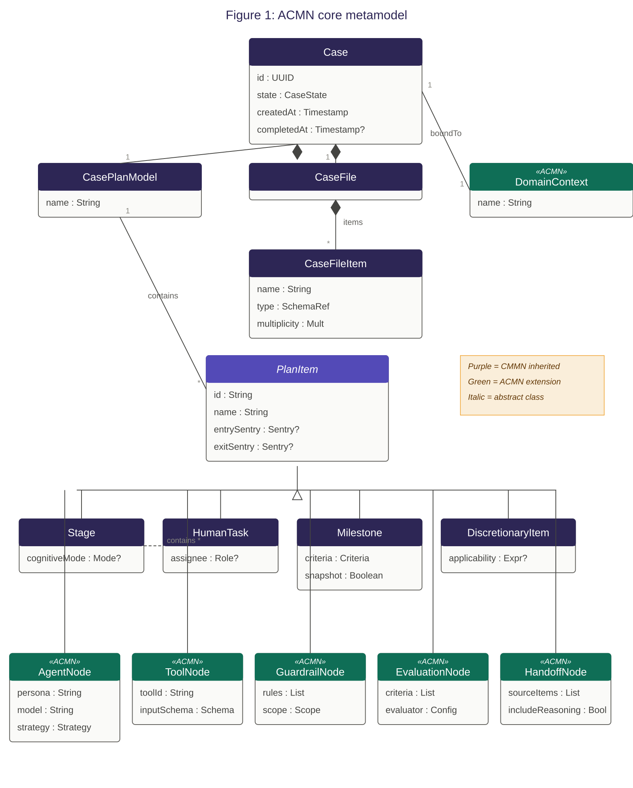

5. CMMN inherited elements
The following elements are inherited from CMMN 1.1. Their definitions, attributes, and lifecycle semantics are as specified in the CMMN standard unless explicitly extended below.

5.1 Case
A case is the top-level modelling element. A case defines a case plan model and a case file. In ACMN, a case is additionally bound to a domain context (see Section 9).
NOTE: CMMN defines the case as containing a case plan model, case file, case roles, and input/output parameters. ACMN preserves all of these and adds the domain context binding.

5.2 Case plan model
The case plan model is the container for all plan items within a case. It defines the top-level scope for stages, tasks, milestones, sentries, and — in ACMN — agent nodes, tool nodes, guardrail nodes, and wires. The case plan model is rendered as a bounded rectangle on the visual design surface.

5.3 Stage
A stage is a plan item that acts as a container for other plan items. Stages may be nested (a stage within a stage). In CMMN, stages define a scope for planning. In ACMN, stages are additionally annotated with a cognitive mode.

5.3.1 Cognitive mode (ACMN extension)
Each stage MAY have a cognitive mode attribute with one of the following values:
Mode | Semantics
gather | The stage’s agents are collecting information: querying tools, retrieving documents, receiving input. Agent confidence is typically low and rising.
analyse | The stage’s agents are reasoning about gathered information: comparing, evaluating, classifying, assessing. Agent confidence should be actively tracked.
draft | The stage’s agents are producing output artefacts: recommendations, reports, communications. Output is subject to guardrail evaluation.
review | The stage’s agents or human actors are reviewing prior work. This stage typically contains guardrail nodes and human tasks for approval.
decide | The stage’s agents or human actors are making a final determination. Milestones in this stage represent case outcomes.

Cognitive modes are metadata annotations. They do not alter the execution semantics of the stage. Implementations MAY use cognitive modes to influence agent prompt assembly, tool scoping, or visual rendering.

5.4 Case file
The case file is the shared data store within a case. It contains case file items, each of which has a name, a type (referencing a domain entity or value object schema), and a multiplicity. All case participants — agents, human actors, and tools — may read from the case file. Write access is governed by the participant’s context scope (see Section 6.1.4).
ACMN extends the case file with schema validation: case file items are validated against the domain context’s entity and value object schemas on write. Invalid writes are rejected by the runtime.

5.5 Milestone
A milestone is a plan item that represents a verifiable state in the case’s progression. CMMN defines milestones as plan items that complete when their entry sentry is satisfied. ACMN preserves this definition and extends it significantly.

5.5.1 Milestone criteria types (ACMN extension)
ACMN defines three milestone criteria types:
Assertion: A boolean expression evaluated against the case file state. The milestone is achieved when the expression evaluates to true. This is equivalent to CMMN’s milestone semantics.
Confidence: A threshold on an agent’s confidence score, optionally combined with a trajectory requirement. The milestone is achieved when the specified agent’s confidence meets or exceeds the threshold AND the trajectory matches (e.g., rising or stable). This has no CMMN equivalent.
Composite: A combination of assertion and confidence criteria, optionally requiring human validation. The milestone is achieved when all constituent criteria are satisfied. This has no CMMN equivalent.

5.5.2 Milestone achievement and snapshots (ACMN extension)
When a milestone is achieved, the implementation SHALL record: the timestamp of achievement, the identity of the participant whose action triggered achievement, the confidence score of the triggering agent (if applicable), and a snapshot of the complete case state at the moment of achievement.
The snapshot is a serialised copy of: all case file items, all agent instance states (working memory, confidence, turn count), all milestone states, and all wire buffer contents. The snapshot is immutable once created.

5.5.3 Milestone revocation (ACMN extension)
A milestone MAY define a revocation condition — a sentry that, if satisfied after the milestone has been achieved, causes the milestone to revert to the available state. When a milestone is revoked:
- All milestones achieved after the revoked milestone are also revoked (cascading revocation).
- The case state is restored from the revoked milestone’s snapshot.
- The revocation reason is added to the case file as a special case file item visible to agents.
- The stage containing the revoked milestone is re-activated with its entry sentry re-evaluated.

NOTE: Milestone revocation enables agents to recover from incorrect conclusions when new evidence arrives. The audit trail retains a complete record of the revoked work, marked with a rollback indicator.

5.6 Sentry
A sentry is a guard condition on a plan item or stage. A sentry is composed of an on-part (what event or state change triggers evaluation) and an optional if-part (what condition must be true for the sentry to be satisfied). ACMN preserves CMMN’s sentry model and extends it.
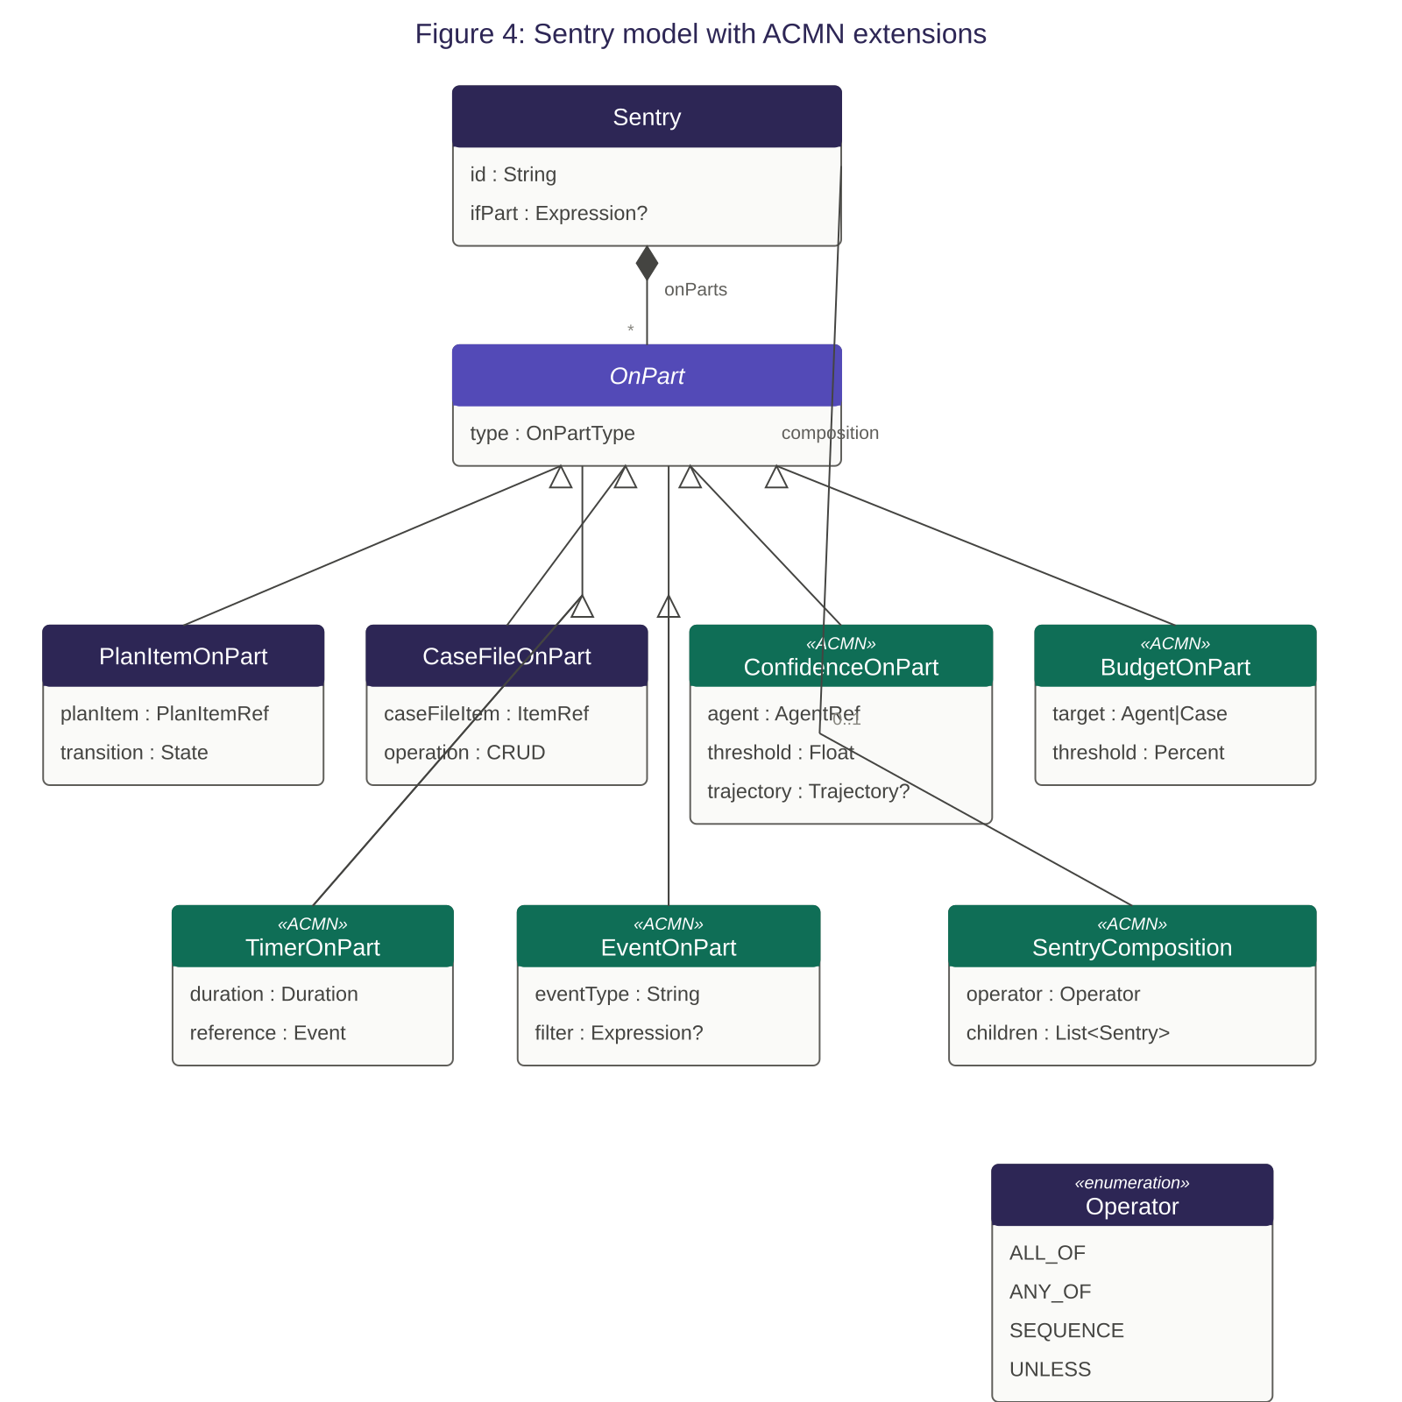

5.6.1 On-part types (ACMN extension)
CMMN defines two on-part types: plan item on-parts (triggered by plan item transitions) and case file item on-parts (triggered by case file changes). ACMN adds four additional on-part types:
On-part type | Trigger condition
Plan item | (CMMN) A plan item transitions to a specified state (e.g., completed, terminated, failed).
Case file item | (CMMN) A case file item is created, updated, or deleted.
Confidence | (ACMN) An agent’s confidence score crosses a specified threshold or changes trajectory.
Budget | (ACMN) Token consumption for an agent or case reaches a specified threshold (e.g., 80%, 90%, 100% of budget).
Timer | (ACMN) A specified duration has elapsed since a reference point (case creation, stage entry, milestone achievement).
Event | (ACMN) A named event is published on the event bus matching the on-part’s event type filter.

5.6.2 Sentry composition (ACMN extension)
ACMN introduces composition operators that combine multiple sentries into compound conditions:
all_of: All composed sentries must be satisfied. Equivalent to logical AND.
any_of: At least one composed sentry must be satisfied. Equivalent to logical OR.
sequence: Sentries must be satisfied in the specified order. The second sentry is only evaluated after the first is satisfied.
unless: The primary sentry is satisfied AND the negation sentry is NOT satisfied. Used for exclusion conditions.
Composition operators may be nested. Implementations SHALL evaluate composed sentries in the following priority order when multiple sentries have pending on-parts: plan item, case file item, confidence, budget, timer, event.

5.7 Human task
A human task is a plan item that requires a human actor to perform work. ACMN preserves CMMN’s human task semantics without modification. Human tasks may appear alongside agent nodes within a stage, enabling mixed human-agent collaboration within a single case.

5.8 Discretionary item
A discretionary item is a plan item that case participants may choose to activate. In CMMN, only human actors activate discretionary items through the planning table. In ACMN, agents MAY also activate discretionary items, subject to their tool access and context scope permissions.

5.8 Discretionary item
A discretionary item is a plan item that case participants may choose to activate. In CMMN, only human actors activate discretionary items through the planning table. In ACMN, agents MAY also activate discretionary items, subject to their tool access and context scope permissions.

5.9 Plan item decorators
CMMN defines a set of decorators — visual markers and behavioural properties — that modify how plan items participate in stage and case completion, activation, and repetition. ACMN preserves all CMMN decorators and extends their applicability to ACMN extension elements.

5.9.1 Decorator definitions
Decorator | Marker | Semantics
Required | ! | The plan item MUST complete (or terminate) before its containing stage or case plan model can complete. A stage with three plan items, two marked required, cannot complete until both required items have reached a terminal state — even if the third item is still available or active.
Repetition | # | The plan item can be instantiated multiple times within its containing stage. When a repeatable plan item completes, a new instance MAY be created if the plan item’s entry sentry is satisfied again. This enables iterative patterns without milestone revocation: an agent node marked with repetition can execute, complete, and execute again when new data arrives.
AutoComplete | ■ | Applies to stages and the case plan model only. When set, the container automatically completes when all its required plan items have reached a terminal state, without needing an explicit exit sentry. When not set, the container stays active until its exit sentry is satisfied, even if all work is done. Default: not set (explicit exit sentry required).
Manual activation | ▷ | The plan item does not activate automatically when its entry sentry is satisfied. Instead, it transitions to an enabled state and waits for explicit activation by a case participant. In CMMN, only human actors perform manual activation. In ACMN, agents MAY also manually activate plan items, subject to their context scope permissions.
Planning table | ⊞ | Applies to stages and the case plan model. The planning table defines which discretionary items are available for activation within the container. Discretionary items not listed in the planning table cannot be activated. In ACMN, the planning table also governs which discretionary items agents can see and choose to activate.

5.9.2 Plan item lifecycle with decorators
The decorators modify the standard plan item lifecycle defined by CMMN. The key interactions are:
Required + stage completion: When a stage’s autoComplete is set, the stage evaluates completion by checking whether all plan items marked required have reached a terminal state (completed, terminated, or failed). Non-required plan items are ignored in this evaluation. If autoComplete is not set, the stage relies on its exit sentry regardless of required item status.
Manual activation + entry sentry: A plan item with manual activation transitions through: available → enabled (when entry sentry is satisfied) → active (when a participant explicitly activates it). Without manual activation, the transition is: available → active (immediately when entry sentry is satisfied). The enabled state is where the plan item waits for a participant’s decision.
Repetition + completion: When a repeatable plan item completes, the implementation evaluates its entry sentry again. If satisfied (which may occur immediately if the sentry’s conditions are still true, or later when new data arrives), a new instance is created. The repetition counter tracks how many instances have been created. Implementations MAY define a maximum repetition count to prevent infinite loops.
Manual activation + agents (ACMN): An agent participating in a stage can examine the planning table to discover available discretionary items with manual activation. The agent MAY choose to activate a discretionary item if its context scope grants access. This enables adaptive case management: an agent decides, based on its analysis, that an optional investigation sub-stage should be activated.

5.9.3 Decorator applicability
Not all decorators apply to all element types. The following table defines which decorators are applicable to each CMMN and ACMN element type. A checkmark indicates the decorator is applicable; an empty cell indicates it is not.
Element | Plan  table | Entry  sentry | Exit  sentry | Auto  complete | Manual  activation | Required | Repetition
Case plan model | ✓ |  |  | ✓
Stage | ✓ | ✓ | ✓ | ✓ | ✓ | ✓ | ✓
Human task |  | ✓ | ✓ |  | ✓ | ✓ | ✓
Milestone |  | ✓ |  |  |  | ✓ | ✓
Event listener
Case file item

ACMN extension elements: The following table extends the applicability matrix for ACMN-specific plan item types:
Element | Plan  table | Entry  sentry | Exit  sentry | Auto  complete | Manual  activation | Required | Repetition
Agent node |  | ✓ | ✓ |  | ✓ | ✓ | ✓
Tool node
Guardrail node |  |  |  |  |  | ✓
Evaluation node |  | ✓ |  |  |  | ✓
Handoff node |  | ✓ |  |  |  | ✓

5.9.4 ACMN applicability notes
Agent node: Supports all decorators except planning table and autoComplete (which are container-only). Entry and exit sentries control when the agent activates and terminates. Manual activation enables patterns where the case design makes an agent available but a human or another agent decides whether to actually deploy it. Required ensures the agent must complete its work before the stage can close. Repetition is essential for iterative patterns: an agent can execute, terminate, and be re-instantiated when new evidence arrives — without requiring a milestone revocation.
Tool node: Tool nodes are capability declarations, not executable plan items. They do not participate in the plan item lifecycle and no decorators apply. Tools are invoked by agents, not activated by the runtime.
Guardrail node: Guardrail nodes are evaluated reactively when agent output is produced, not activated through the plan item lifecycle. The required decorator is applicable: a required guardrail means the stage cannot complete unless the guardrail has been evaluated at least once (ensuring that the guardrail wasn’t bypassed by an agent that produced no output).
Evaluation node: Entry sentry controls when the evaluation node becomes active (typically satisfied when the upstream agent produces its first output). Required ensures evaluation must complete (pass or exhaust retries) before the stage can close.
Handoff node: Entry sentry controls when the handoff becomes available. Required ensures the handoff must execute before the stage completes — useful when a stage’s purpose is to prepare and deliver a handoff bundle to the next stage’s participants.

5.10 Case intake (ACMN extension)
CMMN does not define how cases are created — cases are assumed to be instantiated by external action. ACMN introduces the case intake as a first-class element that models how external signals are received, evaluated, and converted into case instances. Case intake is essential for autonomous agentic systems where cases should be created without human intervention when qualifying events occur in the external world.
A case intake definition is a peer of the case plan model, not a child of it. It sits upstream of the case plan model and defines the pathway from external signal to case instantiation. A domain context MAY have multiple intake definitions — for example, an employee onboarding domain might have one intake monitoring a payroll inbox, another receiving webhooks from the HR system, and a third for manual creation via a web form.

5.10.1 Intake structure
A case intake comprises three elements in sequence:
Signal source: The connection to the external world. Defines where and how the intake listens for potential case-initiating events.
Intake agent: An agent that evaluates the raw signal, classifies it, extracts structured data, and produces an intake decision.
Intake queue: A staging area where positive intake decisions await case instantiation, subject to review, deduplication, and routing rules.

5.10.2 Signal source
A signal source defines the external connection point that delivers raw data to the intake for evaluation. ACMN defines the following signal source types:
Source type | Semantics
Email | Monitors an email inbox. Configurable filters: sender patterns, subject patterns, folder, attachment presence. Each matching email is delivered to the intake agent as a signal.
Webhook | Exposes an HTTP endpoint. External systems POST data to this endpoint. Each request is delivered to the intake agent as a signal.
File watch | Monitors a directory or object storage path for new files. Each new file (PDF, CSV, image, etc.) is delivered to the intake agent as a signal.
Schedule | Polls an external system on a defined schedule (cron expression). Each poll result that meets filter criteria is delivered to the intake agent as a signal.
Event | Subscribes to the ACMN event bus. Enables cross-domain case spawning: an event published in one domain triggers case creation in another.
Manual | A human explicitly creates a case through the platform’s user interface. The intake agent is bypassed — the human provides classification and initial data directly.
API | The platform exposes a REST endpoint for programmatic case creation by external systems. May bypass the intake agent if the calling system provides pre-classified, structured data.

5.10.3 Signal source properties
Property | Type | Description
id | UUID | Unique identifier for this signal source.
name | String | Human-readable name (e.g., “Payroll inbox”, “HR webhook”).
sourceType | SignalSourceType | One of the signal source types defined in Section 5.10.2.
connectionConfig | Map | Type-specific connection parameters. For email: server, credentials reference, folder, polling interval. For webhook: endpoint path, authentication method. For file watch: directory path, file pattern. For schedule: cron expression, target system, query.
filterRules | List<Rule>? | Optional pre-filter rules applied before the intake agent is invoked. Signals that fail the filter are discarded without agent evaluation, reducing unnecessary LLM invocations.
active | Boolean | Whether this signal source is currently listening. Default: true.

NOTE: Signal sources are implemented by the Communications Engine in the ACMN Platform’s four-component architecture. The standard defines the signal source types and their properties; implementations choose the specific protocols and libraries for each source type.

5.10.4 Intake agent
The intake agent is a specialised agent that evaluates raw signals and produces structured intake decisions. It reuses the agent node’s property model (Section 6.1) — persona, model configuration, reasoning strategy, confidence model — but operates outside the case plan model with a specific purpose: determine whether a signal represents a new case.
When a signal arrives from a signal source, the intake agent receives:
- The raw signal content: email body, webhook payload, file contents, or poll results.
- The domain vocabulary: so the agent reasons with consistent terminology.
- Relevant decision tables: if the domain context defines intake classification tables.
- Recent intake history: to support deduplication (e.g., “a similar email was classified as onboarding 10 minutes ago for the same employee”).

The intake agent produces an intake decision with the following structure:

5.10.5 Intake decision
Property | Type | Description
classification | String | The case type this signal represents (e.g., “onboarding”, “payslip_query”, “not_relevant”). References a case type defined in the domain context.
isCase | Boolean | Whether this signal should result in case creation. False for signals classified as irrelevant or outside the domain’s scope.
confidence | Float | The intake agent’s confidence in its classification (0.0 to 1.0).
extractedData | Map | Structured data extracted from the signal, validated against the target case plan model’s input schema. This becomes the case’s initial case file data.
casePlanModelRef | String | The case plan model to instantiate. The intake agent selects this based on classification and domain rules.
priority | Enum? | Optional priority assignment for the new case (low, normal, high, urgent). May influence queue ordering and processing speed.
reasoning | String | Natural language explanation of the classification decision. Included in the audit trail for transparency.
duplicateCheckResult | DuplicateCheck? | If the intake agent detected a potential duplicate (a signal about the same subject as an existing or recently created case), this field identifies the potential duplicate case and the similarity assessment.

5.10.6 Intake queue
The intake queue is the staging area between a positive intake decision and case instantiation. Items enter the queue when the intake agent produces a decision where isCase is true. The queue provides four capabilities:
Human review: When the intake agent’s confidence is below a configurable threshold, the intake decision is flagged for human review before case creation. A human reviewer can approve, reject, or modify the classification and extracted data.
Deduplication: The queue checks incoming decisions against existing cases and other items in the queue. If the intake agent’s duplicateCheckResult indicates a potential duplicate, the item is flagged. Implementations SHALL prevent creation of duplicate cases for the same subject without explicit human override.
Routing: The queue may apply routing rules to select the appropriate case plan model version, assign an initial case owner, or direct the case to a specific team. Routing rules may reference decision tables from the domain context.
Batching: Implementations MAY support batched case creation, where queued items are processed at defined intervals rather than immediately. This is useful for high-volume intake scenarios.

5.10.7 Intake queue item lifecycle
An item in the intake queue transitions through the following states:
State | Transition | Semantics
Received | Initial state | Intake decision received from the intake agent. Deduplication check in progress.
Pending review | Received → Pending | Confidence below threshold or duplicate detected. Awaiting human review.
Approved | Received/Pending → Approved | Classification confirmed (automatically at high confidence, or by human reviewer). Ready for case instantiation.
Instantiated | Approved → Instantiated | Case instance created from the intake decision. The queue item records the case instance ID.
Rejected | Received/Pending → Rejected | Signal determined not to be a valid case (by intake agent at low confidence or by human reviewer). Rejection reason recorded.

5.10.8 Intake properties
Property | Type | Description
name | String | Human-readable name (e.g., “Payroll inbox onboarding intake”).
signalSource | SignalSource | The signal source configuration. See Section 5.10.2.
intakeAgent | AgentConfig | Agent configuration for the intake agent. Reuses agent node properties (Section 6.1).
targetCasePlanModels | List<CasePlanModelRef> | The case plan models this intake can instantiate. The intake agent selects the appropriate model based on classification.
confidenceThreshold | Float | Minimum confidence for automatic case creation. Below this threshold, intake decisions are routed to human review. Default: 0.8.
deduplicationWindow | Duration | Time window for duplicate detection. Signals about the same subject within this window are flagged as potential duplicates. Default: 24 hours.
deduplicationFields | List<String>? | Fields in the extracted data used for duplicate matching. If omitted, deduplication uses the full extracted data.
maxDailyVolume | Integer? | Optional limit on cases created per day from this intake. Prevents runaway case creation from misconfigured signal sources.
active | Boolean | Whether this intake is currently active. Default: true.

5.10.9 Relationship to case plan model and domain context
A case intake is bound to a domain context (it uses the domain’s vocabulary, schemas, and decision tables for classification) and targets one or more case plan models within that domain. The binding relationships are:
- Domain context: One-to-one. The intake operates within a single domain context. The domain’s vocabulary is injected into the intake agent’s context. The domain’s schemas validate the extracted data. The domain’s decision tables may be referenced for classification.
- Case plan models: One-to-many. A single intake can create cases of different types. The intake agent’s classification determines which case plan model is selected. Each target case plan model must belong to the same domain context.

NOTE: The intake agent operates before any case exists. It cannot access case file items, milestones, or sentries because there is no case yet. Its context consists of: the raw signal, the domain vocabulary, applicable decision tables, and recent intake history. After case instantiation, the intake agent’s reasoning trace and the original signal are attached to the new case’s audit trail as the case’s provenance record.

5.10.10 Visual notation
On the design surface, a case intake is rendered upstream of the case plan model:
- Signal source: A rounded rectangle with a distinct icon indicating the source type (envelope for email, lightning bolt for webhook, folder for file watch, clock for schedule, broadcast for event). Positioned at the left edge of the workspace.
- Intake agent: An agent node (using the standard agent node visual form from Section 12.2) positioned between the signal source and the case plan model. Connected to the signal source by a data wire.
- Intake queue: A small rectangular icon with stacked horizontal lines (representing queued items) positioned between the intake agent and the case plan model boundary. Connected to the intake agent by a data wire and to the case plan model by a dashed activation line.

In live monitoring mode, the signal source shows a pulse indicator when signals are being received, the intake agent shows its current classification activity and confidence, and the intake queue shows the count of items in each state (pending, approved, rejected).

6. ACMN extension elements
The following plan item types are defined by ACMN and have no CMMN equivalent.

6.1 Agent node
An agent node is a plan item that represents an autonomous AI participant in a case. An agent node defines the behavioural specification for an agent instance that will be created at runtime when the node’s entry sentry is satisfied.
The agent node has nine property groups:
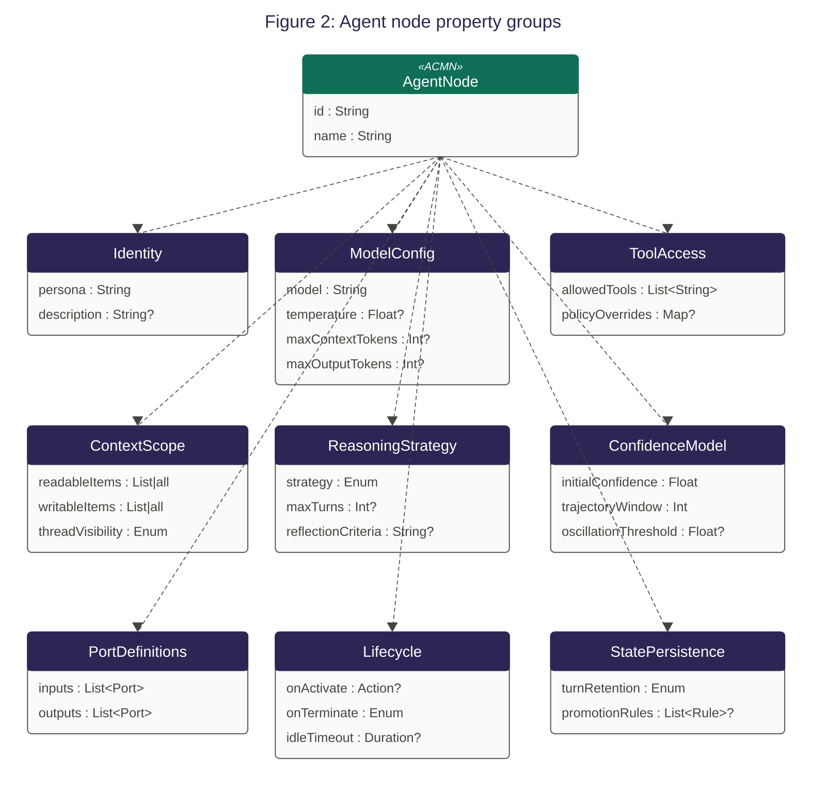

6.1.1 Identity
Property | Type | Description
id | String | Unique identifier within the case plan model.
name | String | Human-readable name displayed on the design surface.
persona | String | Natural language description of the agent’s role, expertise, and behavioural guidelines. Included in the agent’s system prompt.
description | String? | Optional longer description for documentation purposes.

6.1.2 Model configuration
Property | Type | Description
model | String | Model identifier (e.g., “claude-sonnet-4-20250514”). Resolved by the implementation’s model gateway.
temperature | Float? | Sampling temperature. Default determined by implementation.
max_context_tokens | Integer? | Maximum tokens in the assembled context window. Exceeding this triggers priority-based truncation.
max_output_tokens | Integer? | Maximum tokens in the model’s response.

6.1.3 Tool access
Property | Type | Description
allowed_tools | List<String> | Tool IDs this agent may invoke. The agent’s effective tool set is the intersection of: allowed_tools ∩ stage tool scope ∩ domain tool catalogue.
tool_policy_overrides | Map<String, Policy>? | Per-tool invocation policy overrides (auto, confirm_first, supervised). Overrides the tool’s default policy for this agent.

6.1.4 Context scope
Property | Type | Description
readable_case_file_items | List<String>|"all" | Which case file items the agent can see in its context window.
writable_case_file_items | List<String>|"all" | Which case file items the agent can write to.
thread_visibility | Enum | own (sees only its own turns), stage (sees all turns in current stage), case (sees all turns in the case).

6.1.5 Reasoning strategy
Property | Type | Description
strategy | Enum | react (single LLM call per turn), plan_execute (planning phase then step execution), reflect (output + self-evaluation), debate (multi-perspective synthesis).
max_turns | Integer? | Maximum number of turns before the agent is terminated. Default: no limit.
reflection_criteria | String? | Criteria for the reflect strategy’s self-evaluation pass. Required if strategy is reflect.

6.1.6 Confidence model
Property | Type | Description
initial_confidence | Float | Confidence score assigned when the agent instance is created. Default: 0.5.
trajectory_window | Integer | Number of recent turns used to compute confidence trajectory. Default: 5.
oscillation_threshold | Float? | If confidence swings by more than this amount between consecutive turns, trajectory is classified as oscillating.

6.1.7 Input/output ports
An agent node MAY define named input ports and named output ports. Each port has a name and a type (referencing a domain entity schema, value object schema, or built-in type). Ports are the connection points for data wires (see Section 7).
An agent node also has two implicit ports that are always present: an error output port (emitting structured error information when the agent encounters an unrecoverable problem) and a handoff output port (emitting a handoff context bundle when the agent requests escalation).

6.1.8 Lifecycle
Property | Type | Description
on_activate | Action? | Action to execute when the agent instance is created. Typically: initialise working memory.
on_terminate | Enum | archive (preserve full state for forensics) or discard (retain summary only). Default: archive.
idle_timeout | Duration? | If the agent receives no new input for this duration, it is suspended.

6.1.9 State persistence
Property | Type | Description
turn_retention | Enum | full (retain complete turn data in working memory), summary (retain AI-generated summary), result_only (retain only structured output). Default: summary.
promotion_rules | List<Rule>? | Rules for promoting agent state to the case file after each turn or on termination.

6.2 Tool node
A tool node is a plan item that represents an external capability available to agents within the case. A tool node is not a task that executes — it is a declaration that a tool exists and is available for agent invocation.
Property | Type | Description
tool_id | String | Unique identifier. Resolved by the implementation’s tool registry.
name | String | Human-readable name.
description | String | Natural language description of the tool’s purpose. Included in agent prompts.
input_schema | JSON Schema | Expected input parameters.
output_schema | JSON Schema | Expected output format.
invocation_policy | Enum | auto (invoke without approval), confirm_first (require human approval before invocation), supervised (invoke but hold result for human review).

6.3 Guardrail node
A guardrail node is a plan item that defines a constraint on agent output. When an agent produces output, the implementation SHALL evaluate all applicable guardrails before committing the output to the case file.
Property | Type | Description
name | String | Human-readable name.
rules | List<Rule> | Constraint rules. Each rule has a condition expression and a violation action (reject, flag_for_review, annotate).
scope | Enum | agent (applies to a specific agent), stage (applies to all agents in a stage), case (applies to all agents in the case).
evaluation_mode | Enum | rule_based (evaluate condition expressions), llm_based (use an LLM to evaluate the rule in natural language), hybrid (rule-based with LLM fallback for ambiguous cases).

6.4 Handoff node
A handoff node is a plan item that defines how context is transferred between case participants. When an agent or human task triggers a handoff, the handoff node assembles a context bundle from the specified sources and delivers it to the target participant.
Property | Type | Description
source_items | List<String> | Case file items to include in the handoff bundle.
include_reasoning | Boolean | Whether to include the source agent’s reasoning trace. Default: true.
include_confidence | Boolean | Whether to include the source agent’s confidence history. Default: true.
summary_prompt | String? | If provided, an LLM generates a summary of the handoff context using this prompt, rather than including raw data.

6.5 Evaluation node
An evaluation node is a plan item that independently assesses an agent’s output against quality criteria before that output is committed to the case file or delivered downstream via wires. Unlike guardrail nodes (which check binary constraints), evaluation nodes perform qualitative assessment: Is this analysis thorough? Does the recommendation address all evidence? Is the reasoning sound?
The evaluation node creates a feedback loop: when evaluation fails, the evaluator produces structured feedback that is routed back to the producing agent as input for its next turn, enabling the agent to revise and resubmit. This cycle continues until the evaluation passes or the retry limit is reached.
NOTE: Guardrails answer “does this output violate a rule?” Evaluators answer “is this output good enough?” Both are necessary. Guardrails enforce hard constraints (compliance, safety). Evaluators enforce quality expectations (completeness, accuracy, coherence). A well-designed case applies both: guardrails first (reject violations immediately), then evaluators (assess quality of compliant output).
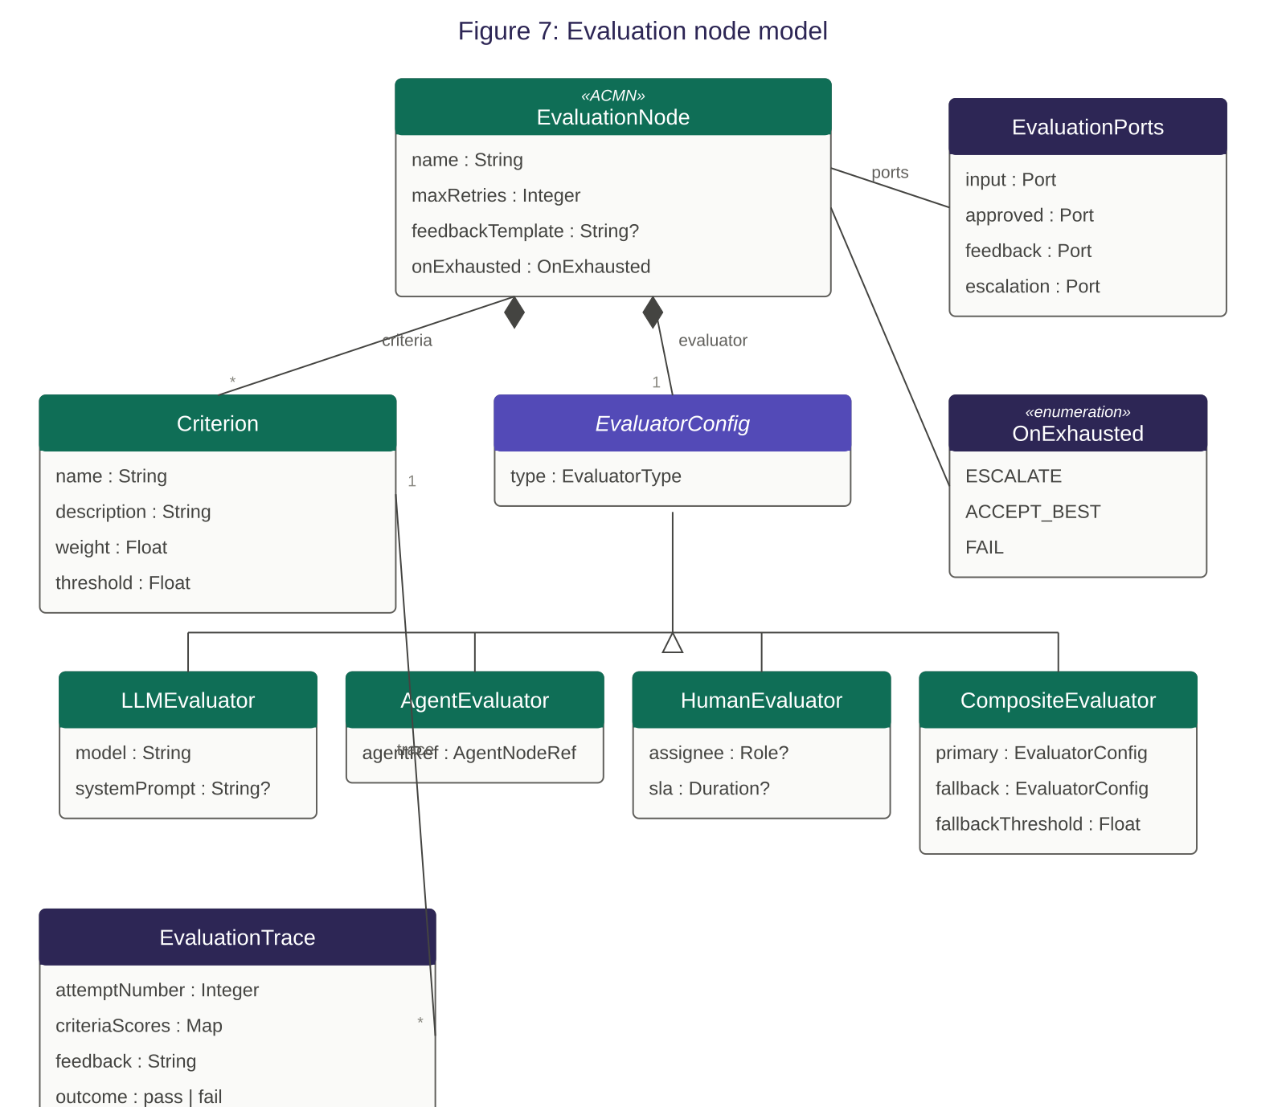

6.5.1 Evaluation node properties
Property | Type | Description
name | String | Human-readable name (e.g., “Assessment quality check”).
criteria | List<Criterion> | Quality criteria the output is assessed against. Each criterion has a name, a natural language description, and a weight (relative importance). See Section 6.5.2.
evaluator | EvaluatorConfig | How evaluation is performed. See Section 6.5.3.
max_retries | Integer | Maximum number of evaluation-feedback-retry cycles before the evaluation node escalates. Default: 3.
feedback_template | String? | Optional template for formatting evaluation feedback before it is sent back to the producing agent. If omitted, the raw evaluation result is used.
on_exhausted | Enum | Action when max_retries is exhausted: escalate (send to human via escalation wire), accept_best (forward the highest-scoring attempt), fail (block output and terminate the producing agent). Default: escalate.

6.5.2 Evaluation criteria
Each criterion defines one dimension of quality. Multiple criteria provide a structured assessment rubric:
Property | Type | Description
name | String | Criterion name (e.g., “Completeness”, “Evidence support”, “Consistency”).
description | String | Natural language description of what constitutes a pass for this criterion. This is included in the evaluator’s prompt.
weight | Float | Relative importance (0.0 to 1.0). Weights across all criteria SHOULD sum to 1.0. Used to compute a composite evaluation score.
threshold | Float | Minimum score (0.0 to 1.0) for this criterion to pass. Default: 0.7.

The overall evaluation passes when all criteria meet their individual thresholds. Implementations MAY additionally compute a weighted composite score across all criteria.

6.5.3 Evaluator configuration
The evaluator property specifies how the evaluation is performed. ACMN defines four evaluator types:
LLM evaluator (default): An LLM assesses the output against the criteria descriptions. The evaluator assembles a prompt containing the agent’s output, the evaluation criteria, relevant case context, and instructions to produce a per-criterion score and natural language feedback. The model used for evaluation SHOULD differ from the producing agent’s model to provide independent assessment.
Agent evaluator: A separate agent node is designated as the evaluator. The agent output is delivered to the evaluator agent via a wire, and the evaluator agent’s output is parsed for pass/fail and feedback. This is the most flexible option — the evaluator agent can use tools, query the case file, and apply domain expertise.
Human evaluator: The output is routed to a human task for review. The human provides a pass/fail decision and optional feedback. This is the slowest but highest-fidelity evaluation method.
Composite evaluator: Combines multiple evaluator types. For example: LLM evaluation first, with human evaluation triggered only when the LLM evaluator’s confidence in its assessment is below a threshold. This enables efficient scaling — most outputs are evaluated automatically, with human review only for borderline cases.

6.5.4 Ports and wiring
An evaluation node has four ports:
Port | Direction | Purpose
input | Input | Receives the output from the agent being evaluated. Connected via a data wire from the agent’s output port.
approved | Output | Forwards output that has passed evaluation. Connected to downstream agents, case file wires, or milestones.
feedback | Output | Sends evaluation feedback back to the producing agent’s input port on evaluation failure. This creates the feedback loop.
escalation | Output | Activated when max_retries is exhausted and on_exhausted is set to escalate. Connects to a human task or more capable agent.

On the design surface, the evaluation node appears between the producing agent and its downstream consumers. The feedback wire from the evaluation node back to the producing agent creates a visible loop that communicates the retry semantics.

6.5.5 Evaluation lifecycle
When an agent produces output on a port connected to an evaluation node, the following sequence occurs:
- The agent’s output is delivered to the evaluation node’s input port.
- The evaluator assesses the output against all criteria, producing a per-criterion score and natural language feedback.
- If all criteria pass their thresholds: the output is forwarded via the approved port. The evaluation trace records a pass.
- If any criterion fails: the evaluation feedback (including which criteria failed, the scores, and the natural language feedback) is delivered to the producing agent via the feedback port. The agent’s retry counter is incremented.
- The producing agent receives the feedback as input on its next turn. The feedback is presented distinctly from other inputs — implementations SHOULD format it as: “Your previous output was evaluated and did not meet the following criteria: [feedback]. Please revise your output.”
- The agent produces revised output, which is again delivered to the evaluation node. The cycle repeats from step (b).
- If the retry counter exceeds max_retries, the on_exhausted action is taken: escalate (output sent to escalation port), accept_best (the attempt with the highest composite score is forwarded via approved port), or fail (output blocked, agent terminated).

The complete evaluation history — every attempt, its per-criterion scores, the feedback provided, and the final outcome — SHALL be recorded in the audit trail as part of the evaluation node’s trace log.

6.5.6 Relationship to guardrails
Guardrail nodes and evaluation nodes serve complementary purposes and may both be applied to the same agent’s output. When both are present, implementations SHALL apply them in the following order:
- Domain rules (Section 9.4) are evaluated first. If any domain rule rejects the output, evaluation does not occur.
- Guardrail nodes are evaluated second. If any guardrail rejects the output, evaluation does not occur.
- Evaluation nodes are evaluated last, only on output that has passed all guardrails.

This ordering ensures that fundamentally non-compliant output is rejected immediately (guardrails) without wasting evaluation resources, while compliant-but-insufficient output enters the evaluation-feedback loop for iterative improvement.

7. Wire model
Wires are typed, directed data connections between ports on plan items. Wires are an ACMN extension with no CMMN equivalent. They complement (not replace) the case file: wires model directed point-to-point data flow between specific plan items, while the case file models shared ambient state.
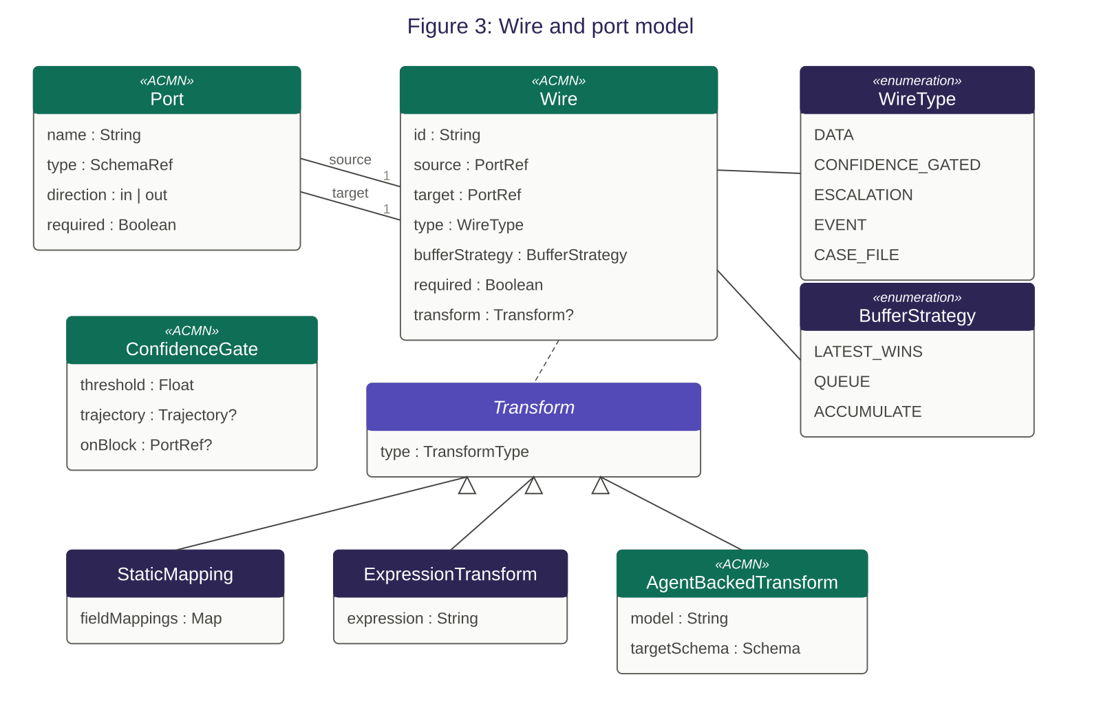

7.1 Wire types
Wire type | Semantics
Data | Carries typed data from an output port to an input port. The default wire type.
Confidence-gated | A data wire with an inline gate. Data flows only when the source agent’s confidence meets the gate’s threshold and trajectory requirements. Blocked data may be routed to an alternative target.
Escalation | Carries handoff context bundles to human tasks or more capable agents. Activated on low confidence, budget exhaustion, guardrail violation, or explicit agent request.
Event | Carries asynchronous events between plan items via the event bus. Can cross stage boundaries.
Case file | Explicitly models a plan item reading from or writing to a specific case file item. Optional — agents can always access the case file through their context scope.

7.2 Wire properties
Property | Type | Description
source | PortRef | node_id.port_name identifying the output port.
target | PortRef | node_id.port_name identifying the input port.
type | Enum | data, confidence_gated, escalation, event, case_file.
buffer_strategy | Enum | latest_wins (retain only most recent value), queue (retain all values in order), accumulate (merge values using a specified strategy). Default: latest_wins.
required | Boolean | If true, the target plan item cannot activate until data has arrived on this wire, in addition to its entry sentry being satisfied. Default: false.
transform | Transform? | An optional inline transform: static_mapping (field renaming/restructuring), expression (computed fields), or agent_backed (LLM-powered prose-to-schema conversion).

7.3 Type compatibility
Wires enforce type compatibility between source and target ports. An implementation SHALL validate wire connections at design time using the following rules:
- Exact match: The output port type equals the input port type. Always valid.
- Subtype: The output port type is a subtype of the input port type (e.g., CollisionClaim is a subtype of Claim). Valid.
- Supertype: The output port type is a supertype of the input port type. WARNING — the target may expect fields that the source does not provide.
- Incompatible: No subtype/supertype relationship exists. ERROR — a transform is required to connect these ports.

8. Event model
ACMN defines an event model for asynchronous communication between case participants and with external systems.

8.1 Event structure
An ACMN event has: a unique identifier, a type (from the domain context’s event catalogue), a delivery scope, a source (the plan item, adapter, or system component that published the event), a typed payload (validated against the event type’s schema), a timestamp, and optional correlation and causation identifiers for event tracing.

8.2 Delivery scopes
Case: The event is delivered only within the originating case instance. This is the default scope.
Domain: The event is delivered to all active case instances within the same domain context, subject to subscription filters.
Organisation: The event is delivered across all domain contexts. Reserved for system-wide events.
External: The event originates from outside the ACMN runtime and enters through an adapter. External events are always targeted to a specific case or domain.

8.3 System events
Implementations SHALL publish the following system events on the event bus. These events are case-scoped and cannot be published by agents:
- agent.activated, agent.suspended, agent.terminated
- milestone.achieved, milestone.revoked
- stage.entered, stage.exited
- guardrail.violated
- budget.warning (at configurable thresholds)
- case.rollback

9. Domain context model
A domain context defines the semantic framework within which a case operates. It provides the shared language, data structures, and governance rules that ensure all case participants — agents, human actors, and tools — operate with consistent meaning. A case is bound to exactly one domain context at creation time.
The domain context model draws on the concept of a bounded context from Domain-Driven Design. ACMN adopts three core ideas from DDD: a shared vocabulary (ubiquitous language), typed schemas for domain data (entities and value objects), and domain-wide invariants (business rules). These three elements are normative. Implementations at conformance Level 3 SHALL support all three.
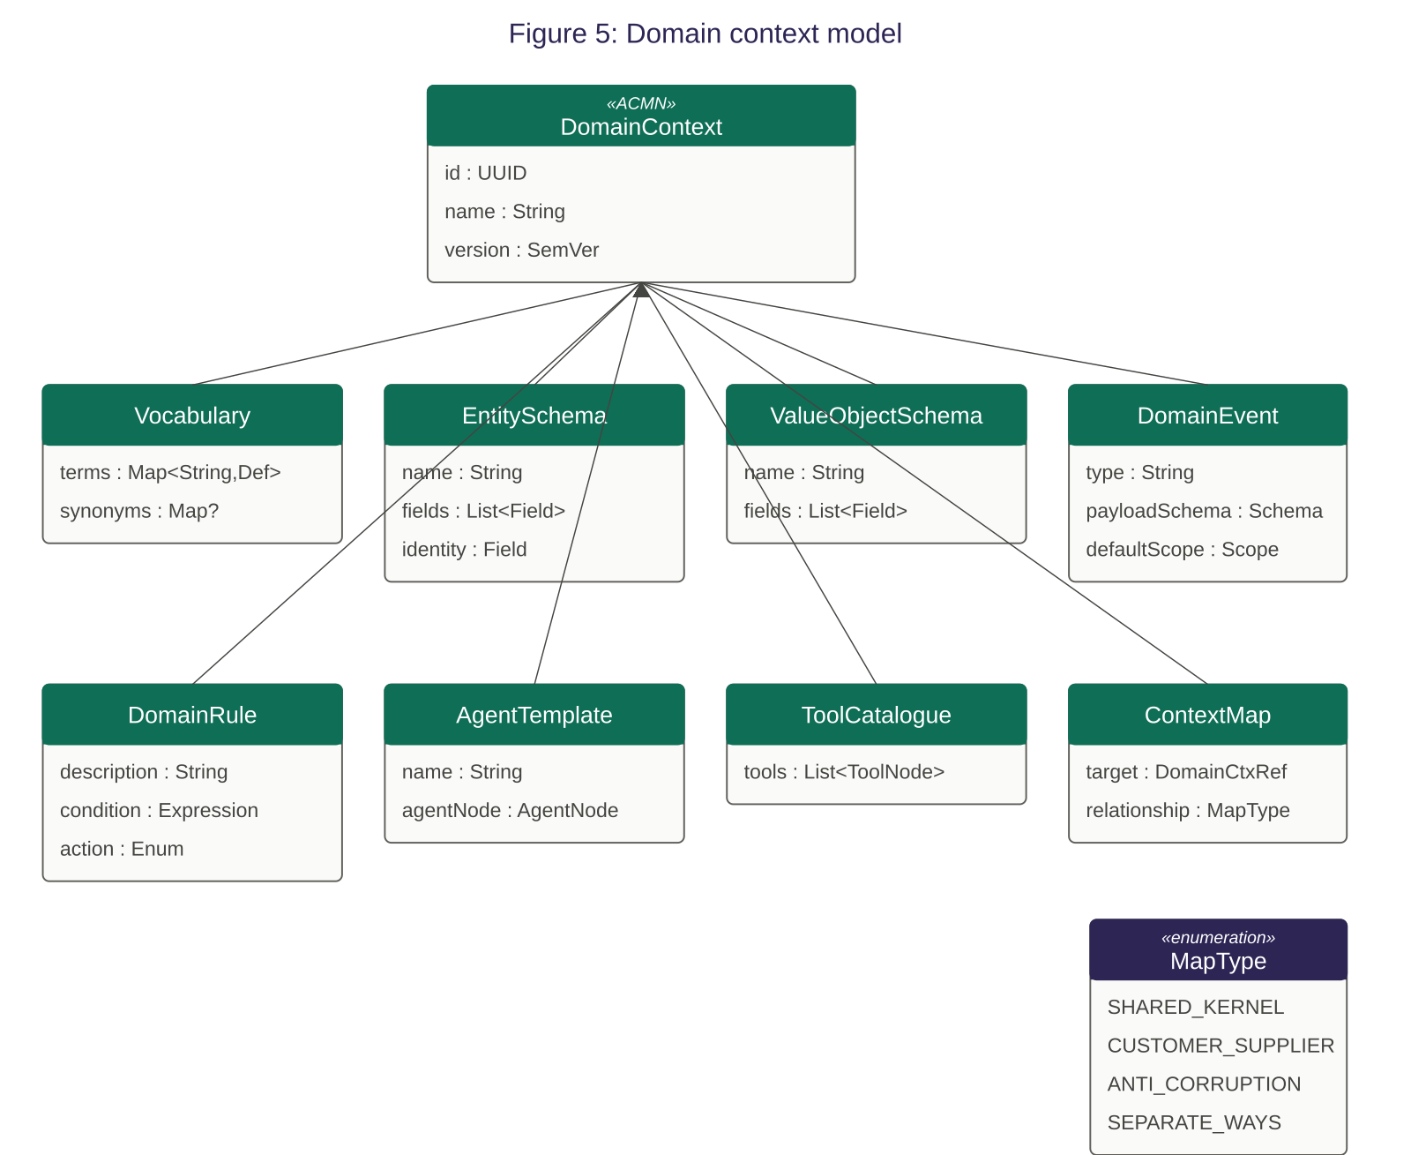
NOTE: The UML diagram above shows the complete domain context metamodel. The normative requirements below focus on the three core elements: vocabulary, schemas, and domain rules. The remaining elements (domain events, agent templates, tool catalogues, context mapping) are informative — implementations MAY support them but are not required to.

9.1 Domain context properties
Property | Type | Description
id | UUID | Unique identifier for this domain context.
name | String | Human-readable domain name (e.g., “Insurance claims”, “Procurement”).
version | SemVer | Semantic version. Cases are bound to a specific version at creation.
vocabulary | Vocabulary | Required. The domain’s shared terminology. See Section 9.2.
entitySchemas | List<Schema> | Required. Typed schemas for domain entities. See Section 9.3.
valueObjectSchemas | List<Schema> | Required. Typed schemas for domain value objects. See Section 9.3.
domainRules | List<Rule> | Required. Business invariants for all cases in this domain. See Section 9.4.
decisionModels | List<DecisionModel>? | Optional. Collections of decision tables codifying domain decision logic. See Section 9.5.
domainEvents | List<EventType>? | Optional. Catalogue of typed events with payload schemas for this domain.
toolCatalogue | List<ToolRef>? | Optional. Tools available within this domain context.

9.2 Vocabulary
The vocabulary is a glossary of domain terms, each with a name and a natural language definition. It establishes the shared language that all case participants use. In an insurance claims domain, the vocabulary defines what “claim,” “claimant,” “settlement,” and “excess” mean precisely, preventing ambiguity when agents reason about these concepts.

9.2.1 Vocabulary structure
Property | Type | Description
terms | Map<String, Def> | Map of term names to definitions. Each definition is a natural language string.
synonyms | Map<String, String>? | Optional map of synonyms to canonical terms (e.g., “repair shop” → “repairer”). Used by implementations to normalise terminology.

9.2.2 Vocabulary injection
Implementations SHALL make the domain vocabulary available to agents during context assembly. The vocabulary SHOULD be included in the agent’s context before case-specific data, so that the agent understands domain terminology before encountering domain-specific content.
The mechanism of inclusion is an implementation choice. Typical approaches include: formatting the vocabulary as a glossary section in the agent’s system prompt, providing it as a reference document in the agent’s context, or embedding term definitions inline alongside case file items that use those terms.
NOTE: The vocabulary serves a dual purpose. First, it gives agents consistent terminology for reasoning — an agent that knows the domain definition of “excess” won’t confuse it with the everyday meaning. Second, it enables domain-scoped retrieval — when querying domain memory, the vocabulary’s canonical terms produce better matches than ad-hoc terminology.

9.3 Entity and value object schemas
Schemas define the structure of domain data. ACMN distinguishes two kinds, following DDD conventions:
Entity schema: Defines an object with identity and lifecycle. Entities have a unique identifier field, and their identity persists across state changes. Examples: Claim, Policy, Claimant, Order, Employee. Entity instances in the case file can be referenced by other entities and tracked across stages.
Value object schema: Defines an object without identity, characterised entirely by its attributes. Two value objects with the same attributes are interchangeable. Examples: Address, CostEstimate, DamageItem, DateRange. Value objects are typically embedded within entities.

9.3.1 Schema structure
Each schema (entity or value object) defines:
Property | Type | Description
name | String | The schema name. SHOULD match a term in the domain vocabulary.
fields | List<Field> | Ordered list of fields. Each field has a name, a type (primitive, schema reference, or list), and a required flag.
identity | FieldRef? | Entity schemas only. The field that uniquely identifies instances. Value object schemas SHALL NOT have an identity field.

9.3.2 Schema usage
Schemas are referenced in three places within an ACMN model:
- Case file items. Each case file item declares its type by referencing a domain schema. Implementations SHALL validate case file writes against the referenced schema. Invalid writes (missing required fields, wrong field types) SHALL be rejected.
- Port types. Input and output ports on agent nodes, tool nodes, and other plan items declare their data type by referencing a domain schema. Wire type compatibility (Section 7.3) is evaluated against these schema references.
- Event payloads. Domain events (if defined) declare payload schemas. Published events are validated against their event type’s schema.

Schemas support subtype relationships: if schema CollisionClaim extends schema Claim (adding fields specific to collision claims), a port typed as Claim will accept data typed as CollisionClaim (subtype compatibility, per Section 7.3).

9.4 Domain rules
Domain rules are business invariants that apply to every case operating within the domain context. They represent governance constraints that are universal to the domain — regulatory requirements, compliance obligations, risk policies, or fundamental business logic that no individual case should override.

9.4.1 Rule structure
Property | Type | Description
name | String | Human-readable rule name.
description | String | Natural language description of the invariant.
condition | Expression? | For rule-based evaluation: a boolean expression over case state. If omitted, the rule requires LLM-based evaluation using the description.
action | Enum | reject (block the agent output), flag_for_review (queue for human review), annotate (allow but attach a warning).

9.4.2 Inheritance semantics
Domain rules are inherited by every case in the domain as guardrails. The inheritance follows a strict additive model:
- Domain rules cannot be relaxed. A case plan model cannot remove, weaken, or override a domain rule. If the domain rule says “no settlement can exceed policy coverage limit,” no case design can bypass this constraint.
- Case-level guardrails are additive. A case plan model MAY define additional guardrail nodes that apply only to that case. These are evaluated in addition to (not instead of) domain rules.
- Evaluation order. Domain rules SHALL be evaluated before case-level guardrails. If a domain rule rejects agent output, case-level guardrails are not evaluated — the output is already rejected.

NOTE: The governance hierarchy from broadest to narrowest scope is: domain rules → case-level guardrail nodes → agent-level tool policies. Each layer can add constraints but cannot remove constraints imposed by a broader scope.

9.5 Decision models
A decision model is a collection of decision tables that codify how specific decisions are made within the domain. Decision tables provide structured, deterministic decision logic that agents can reference during reasoning, replacing ad-hoc LLM inference with explicit domain expertise for well-understood decision patterns.
ACMN adopts the decision table concept from the OMG Decision Model and Notation (DMN) standard. ACMN does not adopt DMN’s full specification (Decision Requirements Diagrams, FEEL expression language, business knowledge models); it adopts the decision table as a data structure with DMN-compatible semantics for hit policies and rule evaluation.

9.5.1 Decision model structure
Property | Type | Description
name | String | Human-readable name (e.g., “Claim approval routing”, “Risk classification”).
description | String | Natural language description of what decision this model codifies.
tables | List<DecisionTable> | One or more decision tables. A model with multiple tables represents a multi-step decision where the output of one table feeds into another.
applicableStages | List<CognitiveMode>? | Optional. Cognitive modes during which this decision model is relevant. If specified, the model is only included in agent context during matching stages. Default: all stages.

9.5.2 Decision table structure
Property | Type | Description
name | String | Table name.
inputs | List<InputColumn> | Input columns defining the conditions. Each column has a name, a type (referencing a domain schema field or primitive), and an optional label.
outputs | List<OutputColumn> | Output columns defining the results. Each column has a name, a type, and an optional label.
rules | List<Rule> | Rows in the table. Each rule specifies input conditions and corresponding output values. Conditions may use comparison operators, ranges, and lists of values.
hitPolicy | HitPolicy | How to handle rule matching. See Section 9.5.3. Default: UNIQUE.

9.5.3 Hit policies
The hit policy determines the behaviour when evaluating input against the table’s rules. ACMN adopts DMN’s hit policy definitions:
Hit policy | Semantics
UNIQUE | Exactly one rule matches. If zero or more than one rule matches, the result is an error. This is the strictest and most predictable policy.
FIRST | Multiple rules may match. The first matching rule (in table order) determines the output. Rules are prioritised by their position in the table.
PRIORITY | Multiple rules may match. The rule with the highest-priority output value determines the result. Priority is defined by the output column’s value ordering.
COLLECT | All matching rules contribute to the output. The results are returned as a list. Optionally, an aggregation function (sum, count, min, max) is applied to the collected values.
ANY | Multiple rules may match but all matching rules must produce the same output. If outputs differ, the result is an error.

9.5.4 Usage in agent context
Implementations SHALL make relevant decision tables available to agents during context assembly. Decision tables SHOULD be formatted as structured reference material in the agent’s context, presented clearly enough that the agent can apply the table’s logic during reasoning.
An agent reasoning about a claim approval might receive the decision table as:
NOTE: The claim approval routing table in the agent’s context serves the same role as a policy manual on a human adjuster’s desk. The agent consults it when making a determination rather than relying solely on its general knowledge. This makes agent decisions auditable: the audit trail can record not just “the agent recommended approval” but “the agent applied row 3 of the approval routing table, which specifies auto-approval for claims under $5,000 with no fraud indicators.”
Implementations MAY additionally evaluate decision tables programmatically (without LLM invocation) when all input values are available in the case file and the table’s hit policy produces an unambiguous result. In this case, the decision table functions as a deterministic computation rather than a reference for agent reasoning. This is more efficient and fully auditable, but requires that input values exactly match the table’s input column types.

9.5.5 Usage in evaluation
Decision tables may be referenced by evaluation nodes (Section 6.5) as structured scoring rubrics. When an evaluation criterion references a decision table, the evaluator applies the table to assess the agent’s output rather than relying solely on LLM-based quality assessment.
For example, an evaluation criterion “Correct routing” might reference the claim approval routing table. The evaluator checks whether the agent’s recommended action matches the table’s output for the given input values. If the agent recommended “senior review” but the table says “auto-approve” for these inputs, the criterion fails with deterministic, explainable feedback.
This hybrid approach — deterministic evaluation via decision tables for structured criteria, LLM-based evaluation for qualitative criteria — provides the best of both: auditability for rule-based decisions and flexibility for judgement-based assessments.

9.6 Domain context binding
A case is bound to a domain context at creation time. The binding establishes which vocabulary, schemas, and rules apply to the case for its entire lifetime. Implementations SHALL enforce the following binding semantics:
- One domain per case. A case is bound to exactly one domain context. Cross-domain cases are modelled as separate cases with event-based coordination (see Section 8).
- Version binding. The case is bound to the specific version of the domain context that was current at case creation. Changes to the domain context after case creation do not affect running cases.
- Binding is immutable. The domain context binding cannot be changed after case creation. If a domain context version is retired, existing cases continue operating against their bound version.

9.7 Cross-domain relationships (informative)
Domain contexts MAY declare relationships with other domain contexts to enable cross-domain event routing and data transformation. When a case in one domain publishes an event that a case in another domain subscribes to, the event payload may require translation between domain vocabularies and schemas. Implementations MAY provide translation capabilities on cross-domain event subscriptions, such as agent-backed transforms (see Section 7.2) that map between incompatible domain models.
NOTE: This section is informative. The ACMN specification does not prescribe specific patterns for cross-domain relationships. Implementations may draw on Domain-Driven Design’s context mapping patterns (shared kernel, customer-supplier, anti-corruption layer) as design guidance.

10. State models

10.1 Case instance lifecycle
A case instance transitions through the following states:
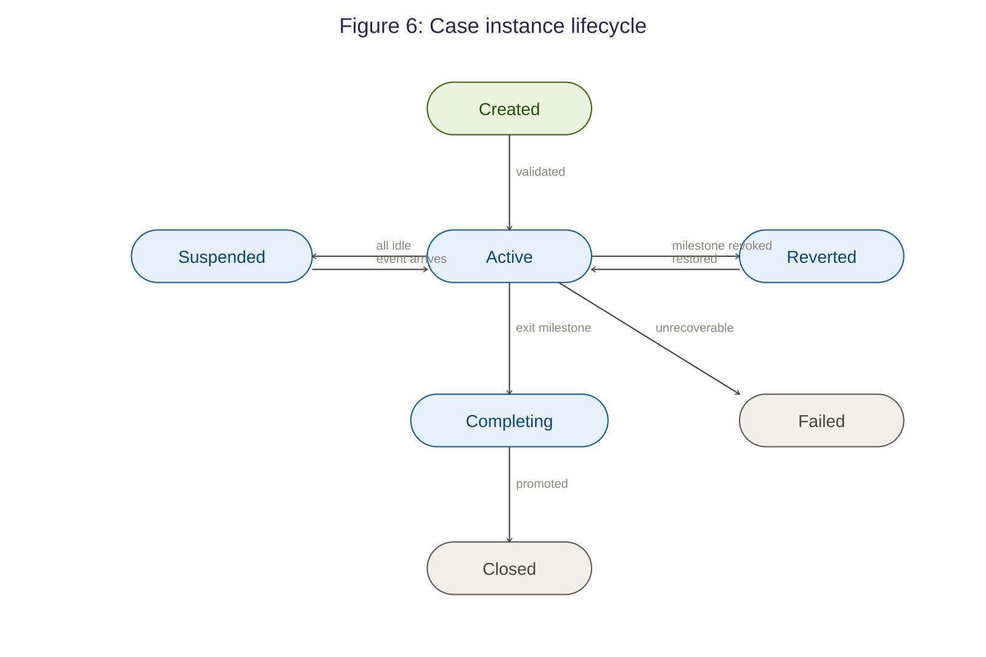
State | Transition | Semantics
Created | Initial state | Case instance created from a case plan model. Domain context bound. Input data validated.
Active | Created → Active | Initial sentries evaluated. First stage activated. Agent turn loop begins.
Suspended | Active → Suspended | All agents idle. Awaiting external event, human input, timer, budget extension, or administrative hold.
Reverted | Active → Reverted | A milestone has been revoked. Case state is being restored from a snapshot. Transient state.
Active | Reverted → Active | Snapshot restored. Revocation reason injected. Stage re-activated.
Completing | Active → Completing | Exit milestone achieved. Agents archived. State promotion rules executing.
Closed | Completing → Closed | All promotions complete. Audit trail sealed. Case file immutable.
Failed | Active → Failed | Unrecoverable error. All escalation paths exhausted.

10.2 Agent instance lifecycle
State | Transition | Semantics
Activating | Initial state | Agent instance created. Working memory initialised. Confidence set to initial_confidence.
Active | Activating → Active | Agent is executing turns. Context assembled, LLM invoked, responses parsed.
Waiting (tool) | Active → Waiting | Agent has requested a tool invocation and is awaiting the result.
Waiting (human) | Active → Waiting | Agent has requested human input (via confirm_first policy or explicit handoff).
Suspended | Active → Suspended | Agent has no pending work. Idle timeout reached or case suspended.
Terminated | Any → Terminated | Agent has completed its work, been explicitly stopped, or the case is closing. on_terminate policy executes.

11. State persistence model
ACMN defines six scopes for state, ordered from narrowest to broadest. Each scope has defined lifetime, visibility, and promotion semantics:
Turn state: Ephemeral. Exists for the duration of a single agent turn. Contains the assembled context window, pending tool calls, and in-progress response. Never persisted.
Agent instance state: Per-agent, per-case. Contains working memory, confidence score, confidence history, turn count, tool results. Persists for the lifetime of the agent instance.
Case state: Per-case. Contains the case file, milestone registry, stage states, wire buffers, thread log, audit trail. Persists for the lifetime of the case instance (and beyond, for closed cases).
Domain memory: Per-domain context. Contains learned resolution patterns, case summary embeddings (for RAG retrieval), and domain-level agent performance metrics. Persists permanently. Updated at case completion via promotion rules.
Organisational memory: Cross-domain. Contains cross-domain patterns and global metrics. Thin layer — most knowledge resides in domain memory. Persists permanently.
Snapshots: Per-milestone. Serialised copies of complete case state taken at milestone achievement. Used for rollback on milestone revocation. Persists for the case lifetime plus a configurable retention period.

State promotes outward selectively: turn results may promote to agent state, agent conclusions may promote to the case file, and case outcomes may promote to domain memory. Promotion rules are declared on agent nodes and milestones. Promotion is never automatic — it occurs only where rules are explicitly defined.

12. Visual notation
This section defines the reference visual notation for ACMN elements on a design surface. The visual notation preserves CMMN’s visual conventions for inherited elements and defines new visual forms for ACMN extension elements.
Conforming implementations SHALL render elements using shapes that are visually distinguishable according to the categories defined below. Implementations MAY use alternative visual styles, colours, icons, and decorators provided that: the structural relationships (containment, connection directionality, sentry attachment) are preserved; each element category remains visually distinct from all other categories; and the port semantics (filled for required/output, open for optional input) are maintained.
NOTE: The reference notation defines shapes, not styles. Colours, fonts, icon sets, animation behaviours, and interaction patterns are implementation choices. The figures in this section illustrate one possible rendering conformant with the specification.

12.1 CMMN inherited visual elements
Element | Visual form | Notes
Case plan model | Large rounded rectangle with case name at top | Outermost boundary. All plan items are contained within.
Stage | Rounded rectangle container with collapse toggle and name bar. Cognitive mode badge in top-right corner. | Contains child plan items. Dashed border when stage is a discretionary item.
Milestone | Diamond shape | Fill colour indicates state: default when available, green when achieved, red on revocation.
Sentry (entry) | Small diamond on the left edge of the guarded element | Filled when satisfied, open when pending.
Sentry (exit) | Small diamond on the right edge of the guarded element | Filled when satisfied, open when pending.
Human task | Rounded rectangle with person icon | CMMN visual convention preserved.
Discretionary item | Same as base element but with dashed border | CMMN visual convention preserved.

12.2 ACMN extension visual elements
Element | Visual form | Notes
Agent node | Rounded rectangle with named input/output ports rendered as small circles on left/right edges. Distinct colour from other plan item types. | Ports: filled circle = required or output, open circle = optional input. Subtitle shows reasoning strategy.
Tool node | Rounded rectangle with distinct colour. Input port (parameters) and output port (result). | Subtitle indicates tool source (MCP, REST, local).
Guardrail node | Rounded rectangle with distinct colour. Input port (agent output) and two output ports: pass and fail. | Pass and fail ports use green and red colouring respectively.
Handoff node | Rounded rectangle with distinct colour. Input port (source state) and output port (context bundle). | Rendered between source and target participants.
Evaluation node | Rounded rectangle with distinct colour. Four ports: input, approved (output), feedback (output, loops back to agent), escalation (output). | Feedback wire from evaluation node back to agent creates a visible loop on the canvas. Shows attempt count and pass/fail history in live mode.

12.3 Wire visual notation
Each wire type has a distinct visual style to ensure data flow, control flow, and escalation paths are immediately distinguishable on the design surface:
Wire type | Visual form | Notes
Data wire | Solid line connecting output port to input port, with directional arrowhead. | Default wire type. Carries typed data.
Confidence-gated | Dashed line with an inline diamond gate showing the threshold value. | Gate diamond indicates open/blocked state.
Escalation | Dashed line with visually distinct colour (red recommended). | Indicates fallback or escalation path.
Event | Dotted line. | Asynchronous event delivery. Can cross stage boundaries.
Case file | Thin solid line connecting a plan item to the case file. | Arrow direction indicates read or write.

12.4 Reference notation figures
The following figures illustrate a conformant rendering of the ACMN visual notation. Implementations MAY use different colours, fonts, and styling while preserving the shape semantics and structural relationships shown.
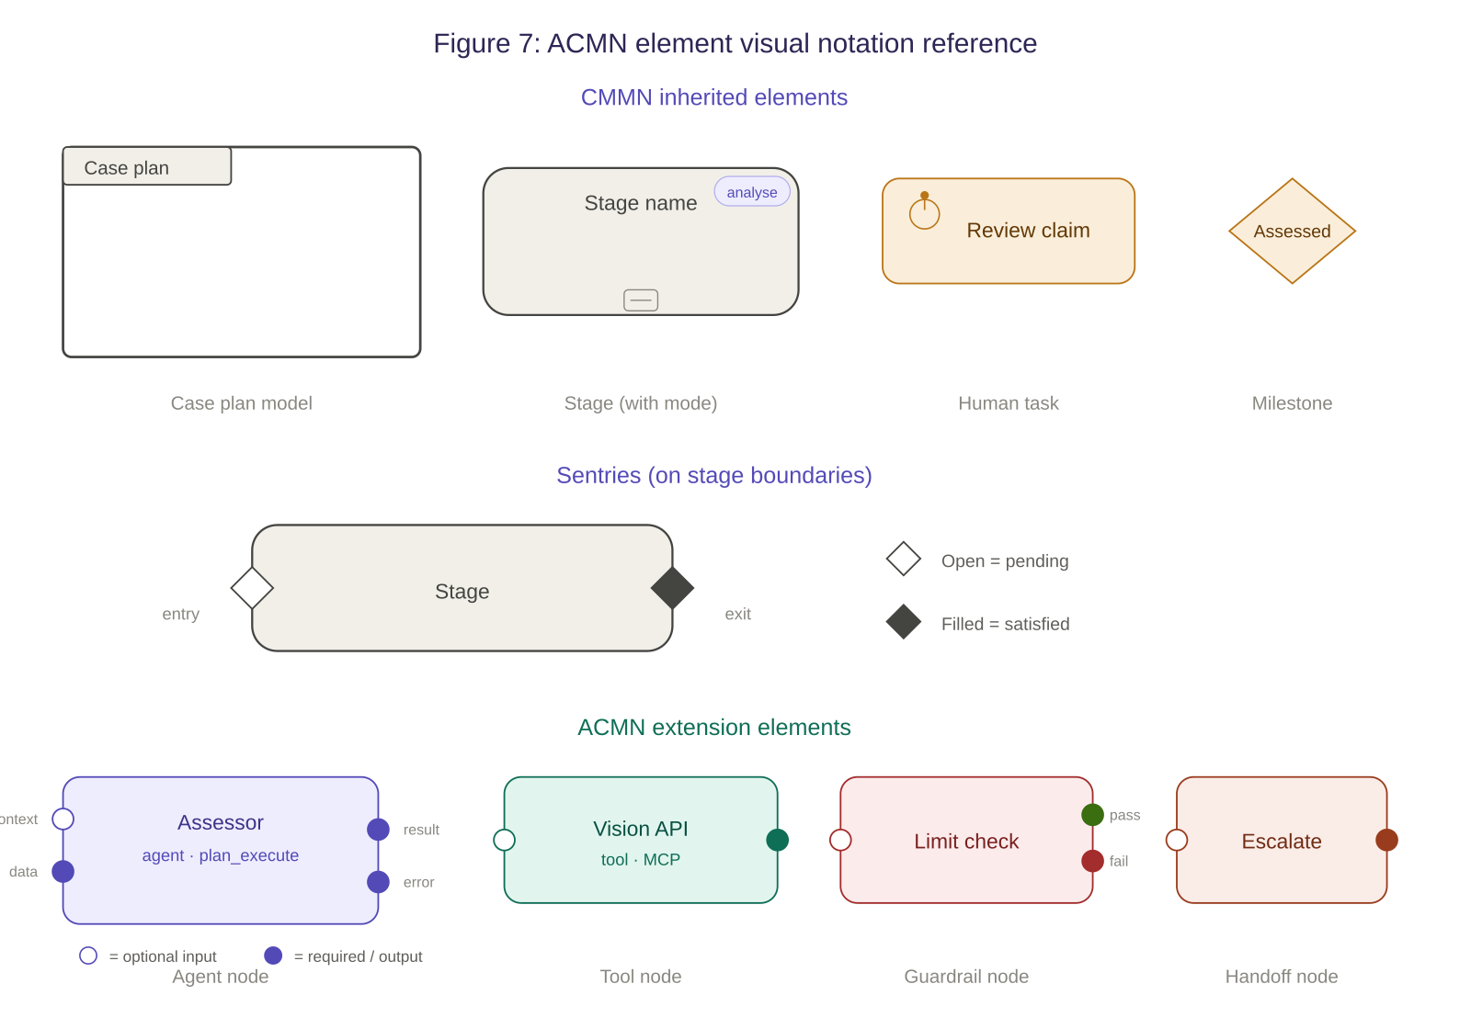
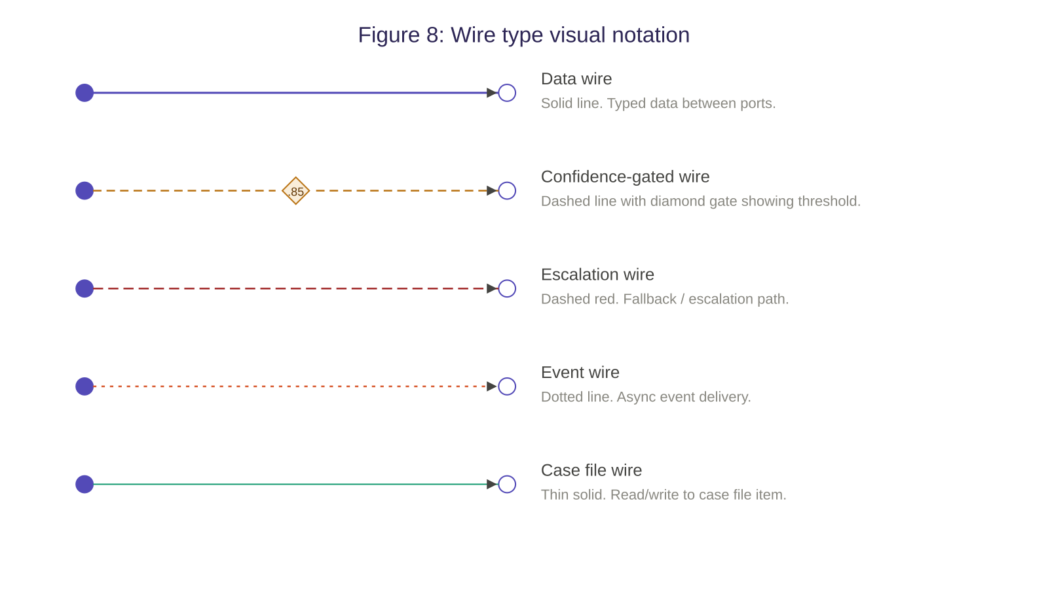
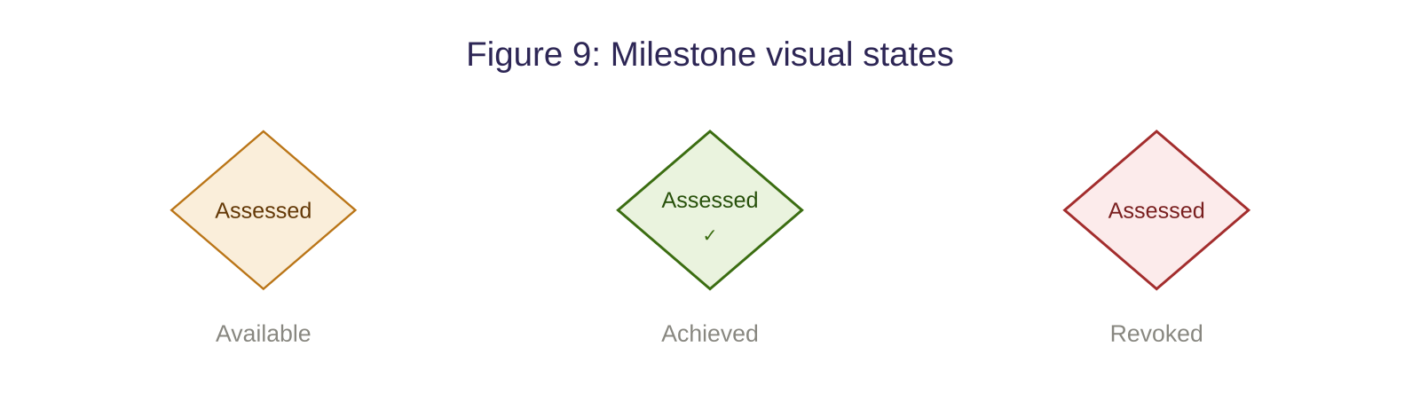

12.5 Complete workspace example
The following figure shows a complete ACMN workspace combining all notation elements: a case plan model containing two stages with sentries, agent nodes with typed ports, a tool node, a guardrail node with pass/fail outputs, a human task for escalation, milestones connecting stages, and data wires, escalation wires, and sentry connections.
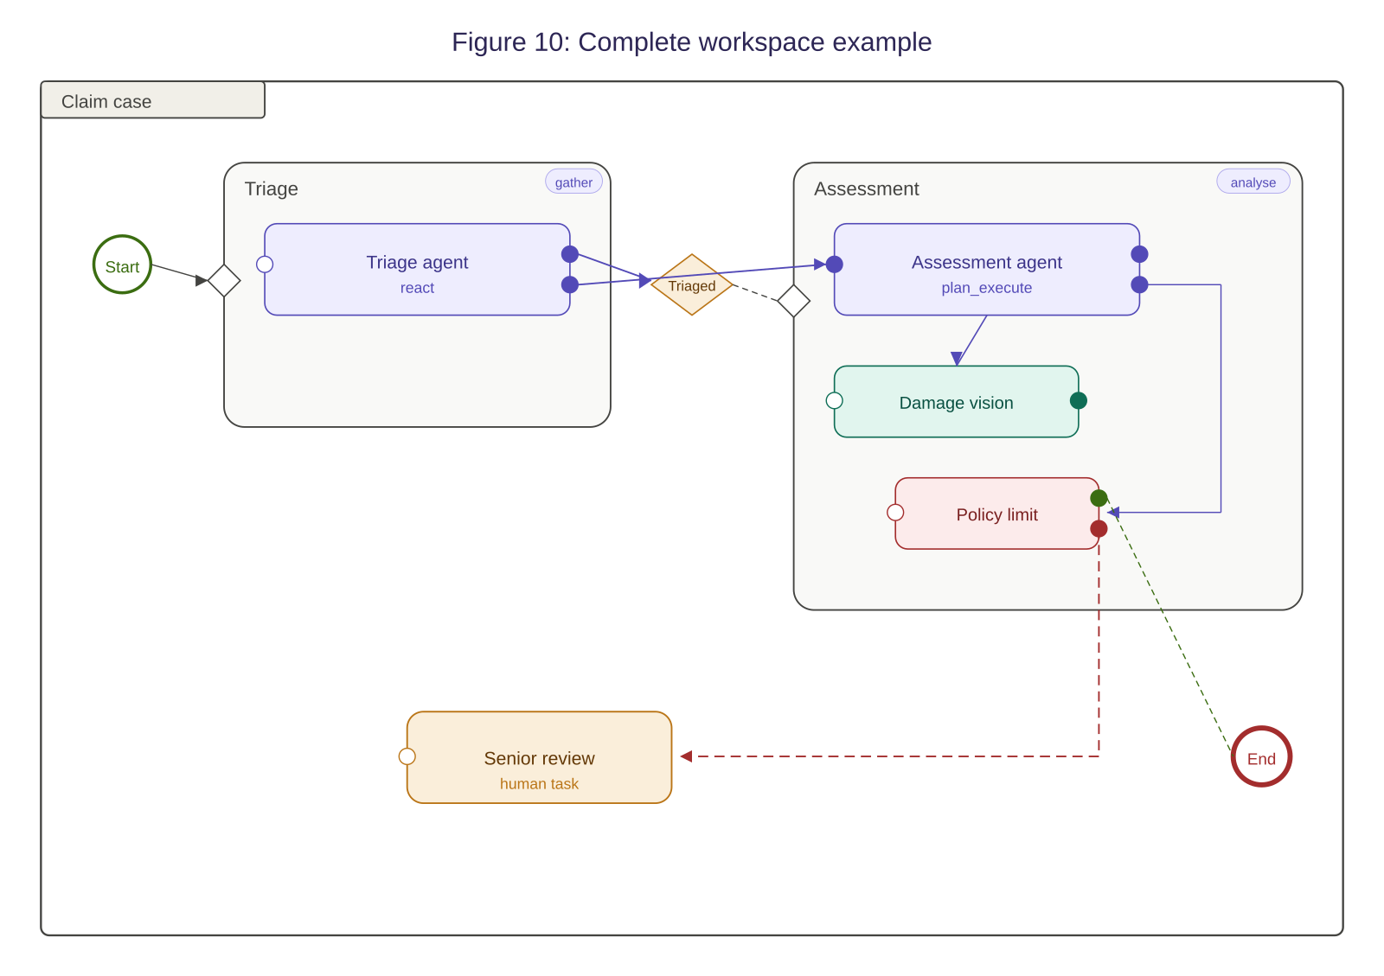

13. Conformance
An implementation conforms to this specification if it satisfies the requirements of one of the following conformance levels:

13.1 Level 1: ACMN Core
An implementation at Level 1 SHALL support:
- Cases, case plan models, stages, milestones (assertion type), sentries (plan item and case file item on-parts), human tasks, and discretionary items as defined in CMMN 1.1.
- Agent nodes with identity, model configuration, tool access, and context scope properties.
- Tool nodes with input/output schemas and invocation policies.
- Data wires with basic type validation.
- Case instance lifecycle: created, active, suspended, closed, failed.
- Agent instance lifecycle: activating, active, suspended, terminated.
- Case file with typed items.

13.2 Level 2: ACMN Extended
An implementation at Level 2 SHALL support all Level 1 requirements plus:
- Confidence milestones and composite milestones.
- Milestone revocation with snapshot and rollback.
- Sentry composition operators (all_of, any_of, sequence, unless).
- Confidence, budget, timer, and event on-part types.
- All five wire types (data, confidence-gated, escalation, event, case file).
- Wire buffering strategies (latest_wins, queue, accumulate).
- Wire transforms (static_mapping, expression, agent_backed).
- Guardrail nodes.
- Evaluation nodes with criteria-based assessment, feedback loops, and retry limits.
- Handoff nodes.
- Reasoning strategies: react, plan_execute, reflect, debate.
- Event bus with case, domain, and external delivery scopes.
- Case instance lifecycle including reverted and completing states.
- Case intake with signal sources, intake agents, and intake queues.

13.3 Level 3: ACMN Complete
An implementation at Level 3 SHALL support all Level 2 requirements plus:
- Domain context model: vocabulary, entity schemas, value object schemas, domain events, domain rules, agent templates, tool catalogues.
- Context mapping between domain contexts (shared kernel, customer-supplier, anti-corruption layer).
- Six-scope state persistence model with promotion rules.
- Domain memory with embedding-based retrieval.
- Cross-case event patterns (spawning, notification, synchronisation).
- Cognitive mode annotations on stages.
- The complete visual notation as defined in Section 12.

NOTE: ACMN Platform, the reference implementation published at github.com/acmn-platform, targets Level 3 conformance.

